Project Title: Smoke detector System Using Gas Sensor

Course Code: BSD 3205

Unit: Embedded Systems

Members:

* + 1. Rose Maina -20/02855
    2. Godfrey Maina -19/03627
    3. Jonathan Kibet- 20/03840
    4. Elly Aseneka-18/05352
    5. Faith Chepkirui- 20/03485
    6. Ruth Mwende -20/03285
    7. Emmanuel- Oduor 20/03203
    8. Basil Juma -20/04915
    9. Alvin Maina -20/04372

10. Brian Nzuki -20/03059

## In this project, we will learn how to create a smoke detector using Arduino. This will help us detect the intensity of gases.

Use Cases

[environmental sensing](https://projecthub.arduino.cc/srajandikshit147/smoke-detector-using-gas-sensor-ecdee6)

[home automation](https://projecthub.arduino.cc/srajandikshit147/smoke-detector-using-gas-sensor-ecdee6)

[smart appliances](https://projecthub.arduino.cc/srajandikshit147/smoke-detector-using-gas-sensor-ecdee6)

Components and supplies

4

Resistor 220 ohm

1

Arduino UNO

1

5 mm LED: Green

1

Buzzer, Piezo

1

Jumper wires (generic)

1

Gas Sensor

1

Breadboard (generic)

1

5 mm LED: Red

Apps and platforms

1

Arduino IDE

1

Tinkercad

Project description

// Pin definitions

const int smokeSensorPin = 7; // Digital pin for the MQ2 sensor

const int buzzerPin = 8; // Digital pin for the buzzer

const int ledPin = 13; // Digital pin for the LED

void setup() {

// Initialize the digital pins

pinMode(smokeSensorPin, INPUT);

pinMode(buzzerPin, OUTPUT);

pinMode(ledPin, OUTPUT);

}

void loop() {

// Read the digital value from the MQ2 sensor

int smokeDetected = digitalRead(smokeSensorPin);

// Check if smoke is detected

if (smokeDetected == LOW) {

// If smoke is detected, sound the buzzer and turn on the LED

digitalWrite(buzzerPin, LOW);

digitalWrite(ledPin, LOW);

delay(1000); // Sound and LED on for 1 second

digitalWrite(buzzerPin, HIGH);

digitalWrite(ledPin, HIGH);

delay(1000); // Pause for 1 second

}

}

Code

Code for smoke Detector

arduino

// Pin definitions

const int smokeSensorPin = 7; // Digital pin for the MQ2 sensor

const int buzzerPin = 8; // Digital pin for the buzzer

const int ledPin = 13; // Digital pin for the LED

void setup() {

// Initialize the digital pins

pinMode(smokeSensorPin, INPUT);

pinMode(buzzerPin, OUTPUT);

pinMode(ledPin, OUTPUT);

}

void loop() {

// Read the digital value from the MQ2 sensor

int smokeDetected = digitalRead(smokeSensorPin);

// Check if smoke is detected

if (smokeDetected == LOW) {

// If smoke is detected, sound the buzzer and turn on the LED

digitalWrite(buzzerPin, LOW);

digitalWrite(ledPin, LOW);

delay(1000); // Sound and LED on for 1 second

digitalWrite(buzzerPin, HIGH);

digitalWrite(ledPin, HIGH);

delay(1000); // Pause for 1 second

}

}

Downloadable files

Schematic of Smoke Detector

Schematic of Smoke Detector

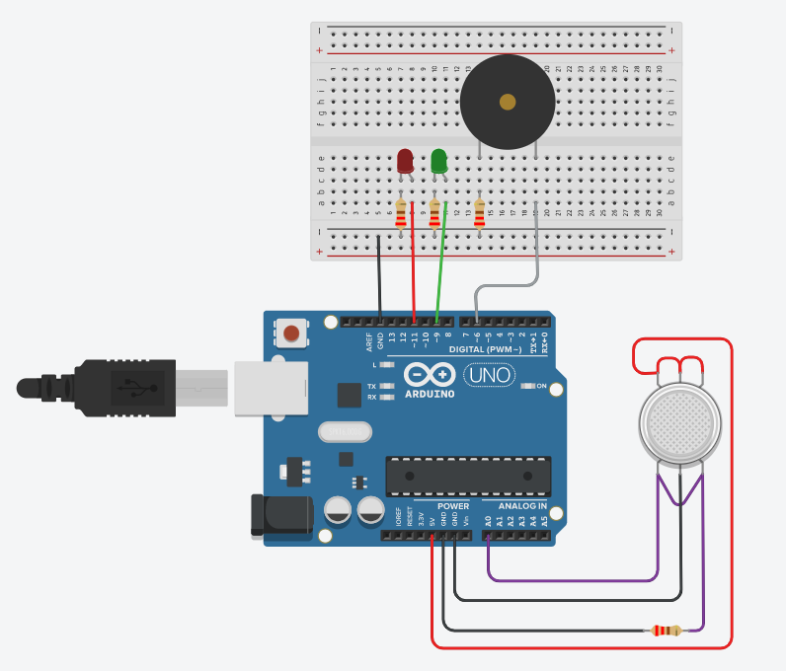

Schematic of Smoke Detector

Schematic of Smoke Detector

